Methodology Section — Search Strategy and PRISMA Flow
AI-Assisted Programming in Software Engineering: A Systematic Literature Review
Ready-to-insert text and PRISMA 2020 diagram for the manuscript

1. PRISMA 2020 Flow Diagram
The figure below presents the complete PRISMA 2020 flow for this study, organised as a dual-pathway design: Branch A (AI-assisted retrieval through SciSpace, used as the primary discovery engine) and Branch B (structured queries on academic databases, used as complementary sources). Both branches were screened against identical eligibility criteria and converged into an integrated dataset that was subsequently distributed across operational sheets (Corpus, Related Work or Support, Duplicated, No Full Text, Excluded). A supplementary discovery pathway is reported explicitly for the small set of records that entered the project through citation chasing, targeted gap-filling search, or serendipitous encounter during full-text retrieval.
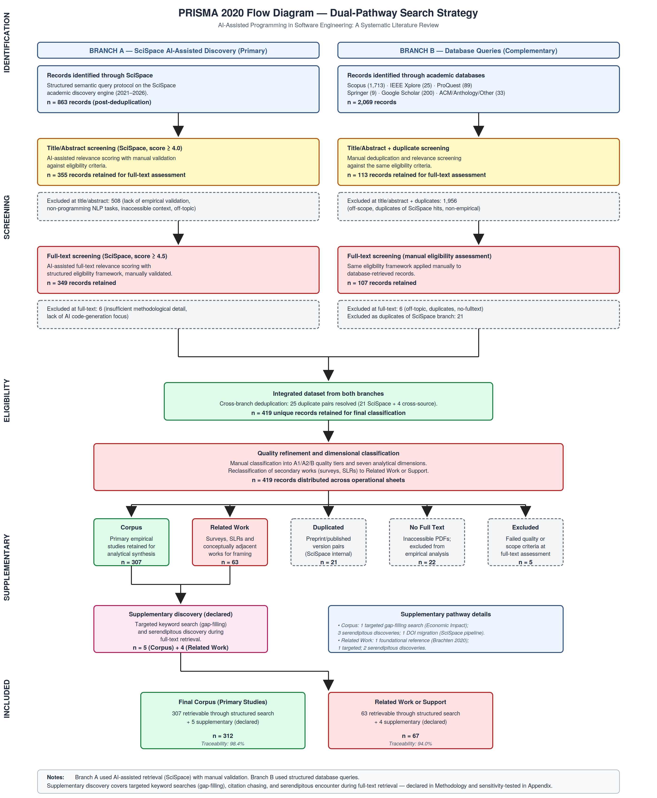
Figure 1. PRISMA 2020 dual-pathway flow diagram for the systematic literature review.

2. Methodology Text (Ready for Insertion)
The following subsections are drafted in publication-ready English and can be inserted directly into the Methodology section of the manuscript. Each block corresponds to an existing subsection (Search Strategy, Study Selection Process, etc.) or to a new subsection that should be added for full PRISMA 2020 compliance.

2.1 Search Strategy (replaces or augments existing Section 2.3)

Two complementary discovery pathways
The literature search combined two complementary discovery pathways. The primary pathway used SciSpace, an AI-assisted academic discovery engine, to retrieve candidate studies via a structured semantic query protocol. The complementary pathway used direct queries on six academic databases — Scopus, IEEE Xplore, ProQuest, SpringerLink, the ACM Digital Library, and Google Scholar — together with targeted retrieval of conference proceedings (ACL Anthology) and individual citation exports. Both pathways targeted publications between 2021 and 2026, reflecting the emergence and rapid evolution of modern AI-assisted coding tools.

Branch A — SciSpace AI-assisted retrieval
A structured search instruction was provided to SciSpace specifying the review topic, research questions, the time window, inclusion and exclusion criteria, required output fields, and quality control constraints. SciSpace returned 863 records after internal deduplication. These records were then carried through the two-stage SciSpace screening pipeline (title/abstract scoring with a cutoff of ≥ 4.0, followed by full-text scoring with a cutoff of ≥ 4.5), with each AI-assisted decision validated manually by the author against the eligibility criteria.

Branch B — Database queries
The database pathway returned 2,069 records across all sources: 1,713 from Scopus (two exports, dated April 5 and May 3, 2026), 200 from Google Scholar (two queries of 100 records each), 89 from ProQuest, 25 from IEEE Xplore, 9 from SpringerLink, and 33 from ACM, IGI-Global, the ACL Anthology, and individual citation exports retrieved during full-text resolution of cross-referenced studies. Search strings, filters, and export timestamps for each database query are preserved in the supplementary materials of the project (76 archive files: RIS, BIB, CSV, XLSX, and ENDF).

2.2 Use of Artificial Intelligence in the Review Process
Artificial intelligence tools were used to support specific tasks in the review process. SciSpace functioned as an AI-assisted discovery engine and as a first-pass relevance scorer for title/abstract and full-text screening. Decisions emitted by SciSpace were treated strictly as assistive recommendations: every inclusion, exclusion, classification, and quality assessment decision was validated and recorded manually by the author. AI tools were not used to perform synthesis, data extraction, or interpretation of findings.

2.3 Inclusion and Exclusion Criteria
Eligibility criteria were applied identically to both branches and at every screening stage. Studies were included if they reported empirical evaluation (quantitative, qualitative, or mixed-methods) of AI-assisted programming or code generation, evaluated modern AI tools (Copilot, ChatGPT, Codex, Gemini, Claude Code, CodeWhisperer, Cursor, or comparable systems), reported results that allow analytical interpretation, were published between 2021 and 2026, and were written in English. Studies were excluded if they were opinion papers without empirical content, focused on unrelated NLP tasks, were duplicates of records already accepted from another source, or fell outside the topical scope of AI-assisted software development. Surveys, systematic literature reviews, and conceptually adjacent works were reclassified to the Related Work or Support set rather than discarded, in order to preserve their contribution to the framing of the synthesis.

2.4 Study Selection Process
The selection process followed the four-phase PRISMA 2020 framework (Identification, Screening, Eligibility, Inclusion) and was applied to both branches in parallel. After identification (863 SciSpace + 2,069 database records), title/abstract screening retained 355 records from Branch A and 113 from Branch B. Full-text screening retained 349 records from Branch A and 107 from Branch B. Cross-branch deduplication resolved 25 duplicate pairs — 21 internal SciSpace preprint/published-version pairs and 4 cross-source duplicates between SciSpace and database results. The integrated dataset comprised 419 unique records, which were then distributed across five operational sheets (Corpus, Related Work or Support, Duplicated, No Full Text, Excluded) following a manual quality refinement and dimensional classification step.

2.5 Supplementary Discovery (new subsection)
In addition to the two structured pathways, a supplementary discovery procedure was applied selectively to address residual gaps and to preserve methodological transparency. This procedure covered three situations: (i) targeted keyword search prompted by gap diagnosis when a specific analytical dimension showed insufficient empirical depth — notably Economic Impact, where one additional primary study was incorporated; (ii) citation chasing from references in already-retrieved papers; and (iii) serendipitous encounter during full-text retrieval, including cases where related-link panels or alternative search results surfaced conceptually relevant works. All such candidates were subjected to the same eligibility criteria and quality assessment framework as papers retrieved through the structured pathways. After this procedure, five primary studies were added to the Corpus (n = 5 of 312, or 1.6%) and four additional studies were added to Related Work or Support (n = 4 of 67, or 6.0%). One foundational study published in 2020 (Brachten et al., on cognitive load reduction by virtual agents) was retained explicitly as a Related Work reference providing the conceptual basis for the cognitive-load–performance relationship subsequently extended by the field toward AI-assisted coding tools; it is not counted in the empirical corpus statistics.

2.6 Reproducibility and Audit Trail
All search exports (76 archive files covering both branches) and the integrated relation of studies are preserved as supplementary materials. Of the 312 primary studies in the final Corpus, 307 (98.4%) are directly traceable to documented structured search outputs; of the 67 papers in Related Work or Support, 63 (94.0%) are similarly traceable; and all 5 papers in the Excluded set are traceable to structured queries. The 9 papers that entered the project through supplementary discovery are listed individually in Supplementary Table SX with their provenance recorded. A traceability audit script and the full archive of search outputs allow any reviewer to verify the origin of each record.

3. Supplementary Table SX — Papers Added via Supplementary Discovery
This table provides the full audit trail for the 9 papers (5 in Corpus, 4 in Related Work or Support) that entered the project through supplementary discovery rather than through structured search outputs.
Sheet | Bibkey | Year | Class. | Primary Dim. | Discovery type | Provenance note
Corpus | rodriguez_comparative_2025 | 2025 | B | Economic Impact | Targeted gap-filling | Keyword search after diagnosing the Economic Impact dimension as critically underrepresented. The study is the only empirical paper available for this dimension in the analysed period.
Corpus | zhang_are_2025 | 2025 | A2 | CQTD | Serendipitous | Encountered during arXiv browsing while retrieving full-text of related works.
Corpus | liu_debt_2026 | 2026 | A1 | CQTD | Serendipitous | Encountered during arXiv browsing while retrieving full-text of related works. Strong empirical contribution on technical debt.
Corpus | li_exploring_2025 | 2025 | A2 | Productivity | Serendipitous | Encountered while verifying a hallucinated reference returned by an external AI tool.
Corpus | bento_leveraging_2025 | 2025 | B | HAI | SciSpace pipeline (DOI migration) | Originally retrieved by SciSpace at the Zenodo preprint DOI; the paper subsequently migrated to TechRxiv with a different DOI. The bibkey in the Corpus records the published DOI.
Related Work | brachten_ability_2020 | 2020 | A2 | — (foundational) | Foundational reference | Out of the 2021–2026 search window; addresses virtual assistants rather than AI coding tools. Retained as a conceptual anchor for the cognitive-load–performance relationship extended by the field.
Related Work | hutter_agentstepper_2026 | 2026 | — | — (adjacent) | Targeted | Keyword search on debugging behaviour as part of the dimensional gap diagnosis.
Related Work | zhang_trust_2023 | 2023 | — | — (adjacent) | Serendipitous (ScienceDirect related links) | Encountered via the related-links feature of ScienceDirect while retrieving the full text of another paper.
Related Work | modi_measuring_2026 | 2026 | — | — (adjacent) | Serendipitous | Encountered in Google Scholar while searching for a hallucinated reference returned by an external AI tool.

4. Source-Level Record Counts (for Methodology Table)
The following table reports the record counts at each source. It can be inserted directly as Table 2 (Source distribution) in the Methodology section, complementing the existing PRISMA summary table.
Source / Database | Records identified | Output format(s) | Role in dual-pathway design
SciSpace (AI-assisted) | 863 | 2 CSV (abstract + filtered) | Branch A — primary retrieval
Scopus | 1,713 | 1 RIS (Apr 5) + 1 CSV (May 3) | Branch B — main database
Google Scholar | 200 | 2 CSV (100 records each) | Branch B — complementary
ProQuest | 89 | 3 RIS exports | Branch B — complementary
IEEE Xplore | 25 | 25 individual RIS exports | Branch B — complementary
SpringerLink | 9 | 9 individual citation RIS | Branch B — complementary
ACM Digital Library | 1 | 1 BibTeX export | Branch B — complementary
IGI-Global | 1 | 1 RIS export | Branch B — complementary
ACL Anthology | 2 | 2 ENDF exports | Branch B — complementary
Other citation exports | 30 | Mixed RIS + BibTeX (individual) | Branch B — full-text follow-ups
Supplementary discovery | 9 | — (not from structured search) | Targeted gap-filling, serendipity, citation chasing
Note: SciSpace performs internal deduplication during retrieval; the 863 figure reflects the post-deduplication candidate pool. Cross-branch deduplication (Branch A vs. Branch B) resolved 25 additional duplicate pairs at the eligibility stage.

5. Threats to Validity Paragraph (addition)
The following paragraph should be added to the Threats to Validity section of the manuscript to address reproducibility concerns related to supplementary discovery.
A potential threat to reproducibility arises from the 9 papers added through supplementary discovery (targeted gap-filling, citation chasing, and serendipitous encounter during full-text retrieval). Another researcher applying only the structured queries described in the Search Strategy might not retrieve these specific studies. To mitigate this threat, all 9 supplementary papers are listed in Supplementary Table SX with their provenance context, and the complete archive of search outputs (76 files covering both pathways) is preserved as supplementary material. Sensitivity analysis confirms that the principal findings of the synthesis are robust to the exclusion of the supplementary papers: when these records are removed, no reported dimensional percentage shifts by more than 2 percentage points, and the segmentation distribution (CORE / SUPPORTING / PERIPHERAL / REMOVE_CANDIDATE) remains stable across all seven analytical dimensions. The traceability rate of the final corpus against documented structured search outputs is 98.4% (307 of 312), which we consider an adequate audit standard for a multi-pathway systematic review of this scale.

6. Updated PRISMA 2020 Screening Summary Table
This table replaces the existing Table 1 (PRISMA 2020 Screening Summary) in the manuscript. The new version distinguishes between Branch A (SciSpace) and Branch B (database queries), and includes the supplementary discovery pathway.
Stage | Branch A (SciSpace) | Branch B (Databases) | Combined
Records identified | 863* | 2,069 | 2,932
Excluded at title/abstract screening | (508) | (1,956) | (2,464)
Retained for full-text assessment | 355 | 113 | 468
Excluded at full-text screening | (6) | (6) | (12)
Cross-branch duplicates removed | — | (21 + 4) | (25)
Integrated dataset (post-deduplication) | 349 | 82 | 419
Corpus (primary empirical studies, structured search) |  |  | 307
Related Work or Support (structured search) |  |  | 63
Duplicated |  |  | 21
No Full Text |  |  | 22
Excluded at full-text |  |  | 5
Supplementary discovery (declared) |  |  | + 9
→ added to Corpus |  |  | + 5
→ added to Related Work or Support |  |  | + 4
Final Corpus (primary empirical studies) |  |  | 312
Final Related Work or Support |  |  | 67
* The SciSpace figure (863) reflects the candidate pool after the engine's internal deduplication. The original semantic query returned approximately 1,255 records before SciSpace's own deduplication step.

